

**TRAINING & DEVELOPMENT**

**A PROJECT REPORT**

SUBMITTED IN PARTIAL FULFILLMENT OF THE REQUIREMENT FOR THE AWARD OF

THE DEGREE OF

**MASTER OF COMPUTER APPLICATION**

**TO**

**RK UNIVERSITY, RAJKOT**

**SUBMITTED BY**

Name of Student Enrollment No.

Ajay Sarasaniya 23SOECA21051

Kartavya Solanki 23SOECA21055

**UNDER THE GUIDANCE OF**

**Internal Guide** **External Guide**

Prof. Madhuri Vaghasma Mr. Pradeep Yadav

Assistant Professor, Team Leader,

CE/IT/MCA Department, Yudiz Solutions,

RK University, Rajkot Ahmedabad - Gujarat

December 2022



**SCHOOL OF ENGINEERING, RK UNIVERSITY, RAJKOT**

**DECLARATION**

We hereby certify that we are the sole authors of this project work and that neither any part of this project work nor the whole of the project work has been submitted for a degree to any other University or Institution. We certify that, to the best of our knowledge, our project work does not infringe upon anyone’s copyright nor violate any proprietary rights and that any ideas, techniques, quotations, or any other material from the work of other people included in our project document, published or otherwise, are fully acknowledged in accordance with the standard referencing practices. We declare that this is a true copy of our project work, including any final revisions, as approved by our project review committee.

**Signature of Students**

**Ajay Sarasaniya (23SOECA21051)**

**Kartavya Solanki (23SOECA21055)**

Ajay Sarasaniya (23SOECA21051) Kartavya Solanki (23SOECA21055)

Date: Date:

Place: Place:

**Industrial Certificate**

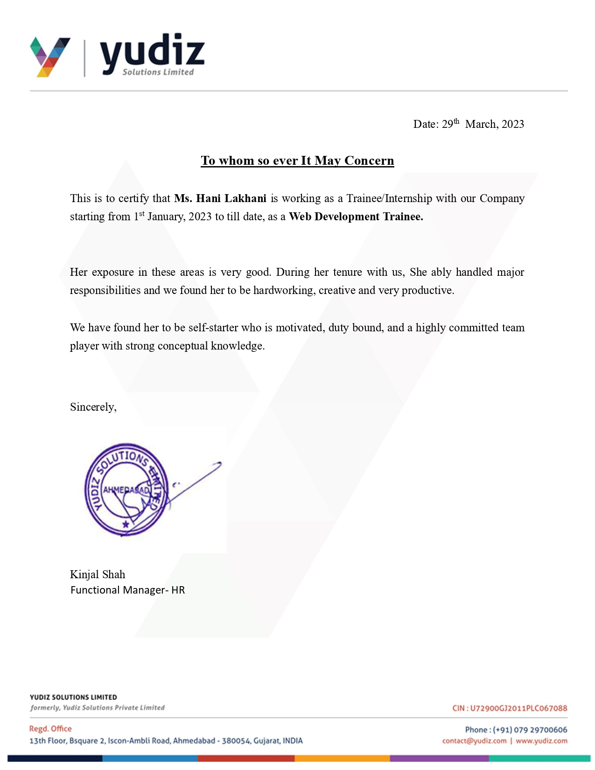



# CERTIFICATE

This is to certify that the work which is being presented in the Project Report entitled **“CONNECTCHAT”,** in partial fulfillment of the requirement for the award of the **MASTER OF COMPUTER APPLICATION** and submitted to the School of Engineering, RK University, is anauthentic record of my/our own work carried out during a period from **July 2024 to December 2024.**

The matter presented in this Project Report has not been submitted by me for the award of any other degree elsewhere.

**Signature of Student**

Ajay Sarasaniya (23SOECA21051)

This is to certify that the above statement made by the student is correct to the best of my knowledge.

|  |  |  |
| --- | --- | --- |
| **Internal Guide** | **External Guide** | **Head of Department** |
| Prof. Madhuri Vaghasma | Mr. Pradeep Yadav | Dr. Paresh Tanna |
| Assistant Professor, | Team Leader, | CE/IT/BCA/MCA |
| CE/IT/MCA Department, | Yudiz Solutions Ltd., | School of Engineering, |
| RK University, Rajkot | Ahmedabad - Gujarat | RK University, Rajkot |
|  | December 2024 |  |



**SCHOOL OF ENGINEERING, RK UNIVERSITY, RAJKOT**



**Acknowledgment**

Apart from the effort of ours, the success of any project depends on the encouragement and guidelines of many others. We take this opportunity to express our gratitude to the people who have been instrumental in the successful completion of this project.

To begin with, we would like to express our special thanks of gratitude to our department and its professors for their valuable contribution in making us capable and worthy of taking up such a challenging project. Taking up and developing this project demanded not only knowledge but also attitude, not only hard work but also the vision, for that, we heartily thank **Prof. Homera Durani** internal project guide of the CE Department.

We place on record and warmly acknowledge the continuous encouragement, invaluable supervision, timely suggestions, and inspired guidance offered by our project guide

**Prof. Homera Durani**.

We shall always remain indebted to Mr. **Kirtan Gajjar**, our project guide and web Developer at **Yudiz Solutions Ltd** (Ahmedabad) for their valuable guidance and a touch of inspiration and motivation throughout the project work, without their help, the work would not have been in the shape. We also heartily thank **Chintan Patel, Pradeep Yadav, and Meet Patel** who greatly helped us in our work by acting as a Tech-Support for us. Finally, at last, we are also very thankful to our friends and our family for their help throughout the work to make the success of Project work.

**Name of Student Enrollment No.**

Ajay Sarasaniya 23SOECA21051

Kartavya Solanki 23SOECA21055

**ABSTRACT**

The main purpose of this project “**CONNECTCHAT**” is to, Trainees can easily Enroll the Course and Complete it’s Training Easily. This project report represents the idea of the Online Training And Assign Task to the Trainees. In This Project Admin can Manage Trainees and Courses easily. The main Purpose of the Project is to new Joinees to easily complete their training.

# LIST OF FIGURES

|  |
| --- |
| **Title** |
|  |
| Fig 1: Project Methodology |
| Fig 2: Data Dictionary |
| Fig 3: Use case Diagram |
| Fig 4: Class Diagram |
| Fig 5: Data Flow Diagram |
| Fig 6: Screenshot – Home Page |
| Fig 7: Screenshot – Sign Up |
| Fig 8: Screenshot – Forgot Password |
| Fig 9: Screenshot – Dashboard |
| Fig 10: Screenshot – Profile |
| Fig 11: Screenshot – My Course |
| Fig 12: Screenshot – Course Content |
| Fig 13: Screenshot – Admin Side Login |
| Fig 14: Screenshot – Admin Dashboard |
| Fig 15: Screenshot – Admin Profile |
| Fig 16: Screenshot – Role List |
| Fig 17: Screenshot – User List |
| Fig 18: Screenshot – Department List |
| Fig 19: Screenshot – Course List |

**LIST OF TABLES**

|  |  |
| --- | --- |
| **Title** | **Page No.** |
| Table 1: Project Profile | 01 |
| Table 2: Schedule Representation | 08 |
| Table 3: Estimation | 11 |
| Table 4: Course | 15 |
| Table 5: Course Assignment | 15 |
| Table 6: Location | 15 |
| Table 7: User Permission | 15 |
| Table 8: Admin Roles | 15 |
| Table 9: Course Feedback | 15 |
| Table 10: Users | 16 |
| Table 11: Admin | 16 |
| Table 12: Course Content | 16 |
| Table 13: Roles Revision | 16 |
| Table 14: Menu | 16 |
| Table 15: User Access Token | 16 |

# Table of Contents

|  |  |  |
| --- | --- | --- |
| **Chapter No.** | **Chapter Title** | **Page No**. |
|  | **Declaration** | **II** |
|  | **Industry Certificate** | **III** |
|  | **Certificate** | **VI** |
|  | **Acknowledgement** | **VII** |
|  | **Abstract** | **VIII** |
|  | **List of Figures** | **IX** |
|  | **List of Tables** | **X** |
|  | **Company Profile** | **XIV** |
| **1** | **INTRODUCTION** |  |
| 1.1 | Project summary | 1 |
| 1.2 | Project Profile | 1 |
| 1.3 | Purpose | 2 |
| 1.4 | Scope | 2 |
| **2** | **PROJECT MANAGEMENT** |  |
| 2.1 | Project planning and scheduling | 10 |
| 2.2 | Risk management | 08 |
| 2.3 | Estimation  2.3.1 Effort Estimation  2.3.2 Cost Estimation | 11 |
| **3.** | **SYSTEM REQUIREMENT STUDY** |  |
| 3.1 | Assumption and Dependencies | 12 |
|  | 3.1.1 Assumption | 12 |
|  | 3.1.2 Dependencies | 12 |

|  |  |  |
| --- | --- | --- |
| **4.** | **SYSTEM ANALYSIS** |  |
| 4.1 | Study of current system | 13 |
| 4.3 | Not included tasks to this Project | 13 |
| 4.4 | Feasibility study | 14 |
| 4.5 | Data Dictionary | 15 |
| **5.** | **SYSTEM DESIGN** |  |
| 5.1 | Use Case Diagram | 17 |
| 5.2 | Class Diagram | 18 |
| 5.3 | Data Flow Diagram | 19 |
| **6.** | **TESTING** |  |
| 6.1 | Unit Testing | 20 |
| 6.2 | Load Testing | 20 |
| 6.3 | Model of Testing | 21 |
| 6.4 | White-Box Testing | 21 |
| 6.5 | Black- Box Testing | 22 |
| 6.6 | Test Case | 24 |
| **7.** | **SCREENSHOTS** | 25 |
| **8.** | **LIMITATIONS AND FUTURE PLAN ENHANCEMENT** | |
| 8.1 | Limitations | 39 |
| 8.2 | Future Plan Enhancement | 39 |
| **9.** | **CONCLUSION** | 40 |
| **10.** | **REFERENCES** | 41 |

**COMPANY PROFILE**

|  |  |
| --- | --- |
| **Company Name** | Yudiz Solutions Ltd. |
| **Company Address** | 13th Floor, Bsquare 2, Iscon, Ambli Rd,  Vikram Nagar,  Ahmedabad,  Gujarat 380054 |
| **Company Establishment** | 2007 |
| **Contact Person** | Pratik Patel |
| **Contact no** | 9712598349 |
| **Website** | [www.yudiz.com](http://www.yudiz.com) |
| **Services** | Game/App Development Website development, Software development, E-Commerce Solutions, Digital Marketing, Designing, Graphics Designing. |

# INTRODUCTION

## PROJECT SUMMARY

The main purpose of this project “**Training & Development**” is to, Trainees can easily Enroll the Course and Complete it’s Training Easily. This project report represents the idea of the Online Training And Assign Task to the Trainees. In This Project Admin Can Manage Trainees and Courses easily. The main Purpose of the Project is to new Joinees to easily complete their training.

## PROJECT PROFILE

|  |  |
| --- | --- |
| **Project title** | **CONNECTCHAT** |
| **Components / Modules** | Registration  Login  Profile  Search user  chatting  File send  Image send |
| **Duration** | 6 Months |
| **Front end** | .NET, Blazor, JavaScript, Html, Css, Bootstrap |
| **Back end** | PostgreSQL, SQL |
| **Operating system** | Windows10 |

*Table 1: Project Profile*

**1.2 PURPOSE**

The purpose of this project is to facilitate seamless and real-time communication through an online chat web application built using .NET Web API and Blazor. This project aims to enhance user interaction by enabling features such as user registration, login, and profile management. Users can search for other registered users and engage in one-to-one chats. The chat functionality is enriched with the ability to send files and images, making it suitable for both personal and professional use. This application provides a user-friendly interface and reliable real-time messaging capabilities to ensure an engaging and efficient communication experience.

**1.3** SCOPE

**Website Front will have the following features:**

1. **Home Page**
   * Displays the website name and logo.
   * Users can log in or register from this page.
   * Includes an attractive design with a side image enhancing the user interface.
2. **Dashboard**
   * Users can search for other registered users from the dashboard.
   * Displays the user's profile on the right side for quick access.
   * Chat functionality includes a list of contacts for easy communication.
   * Includes a carousel showcasing recent messages or important updates with options to start new chats.
   * Categories:
     + Recent Chats
     + Favorite Contacts
     + Online Users
3. **Chat Functionality**
   * Real-time one-to-one chat powered by SignalR for instant messaging.
   * Features include typing indicators and message delivery statuses.
   * Users can send text, images, and files seamlessly.
   * Chat history is stored and displayed for continuity in conversations.
4. **Search Feature**
   * Users can search for other users by various criteria:
     + Name
     + Email
     + Status (Online/Offline)
5. **Messaging Features**
   * File sharing capabilities, allowing users to upload and send documents or images.
   * Emojis and reactions can be integrated for better user engagement.
   * Options to delete or edit sent messages.
6. **User Profile Management**
   * Users can update their profile information, such as name, profile picture, and status message.
   * Displays user details for both self and other participants in the chat.
7. **Notifications**
   * Real-time notifications for new messages, file uploads, and user status changes.
   * Visual indicators for unread messages.

**Admin Panel will have the following features:**

1. **Dashboard**

* User will be able to view below details:
* Total Active Employees
* Last month newly added Users
* Last month newly Started Course
* Last month Completed Course
* Last month Courses Added
* **Last month Courses Update**

1. **Login**

* Admin can login using their registered email and password.

1. **Forgot Password**

* This page will have an input for Email ID and the Admin will receive an email on that. That email will contain a link to reset password from where he/she can reset the password.

1. **Admin Management**

* Admin/Sub-Admin can Add/Edit/Activate/Deactivate/Delete users from Admin Panel.

1. **Role List**
   * Here we can show list like Team lead, Dept. head, Admin(HR), Super Admin
2. **User Management**

Here Admin can see all the employees who registered and all the details of the employees.

1. **My Profile**
   * Admin can view profile information including:

* Profile Picture
* First name
* Last name
* Phone
* Email
* Address
  + Edit Profile
* Admin can edit profile information excluding Email for security reasons.

1. **Change Password**

* Admin can change the password by providing:
* Current Password
* New Password
* Confirm New Password

1. **Logout**

* Admin can log out from the panel by using this feature.

**2. PROJECT MANAGEMENT**

## PROJECT PLANNING & SCHEDULING

#### **Project Development Model**

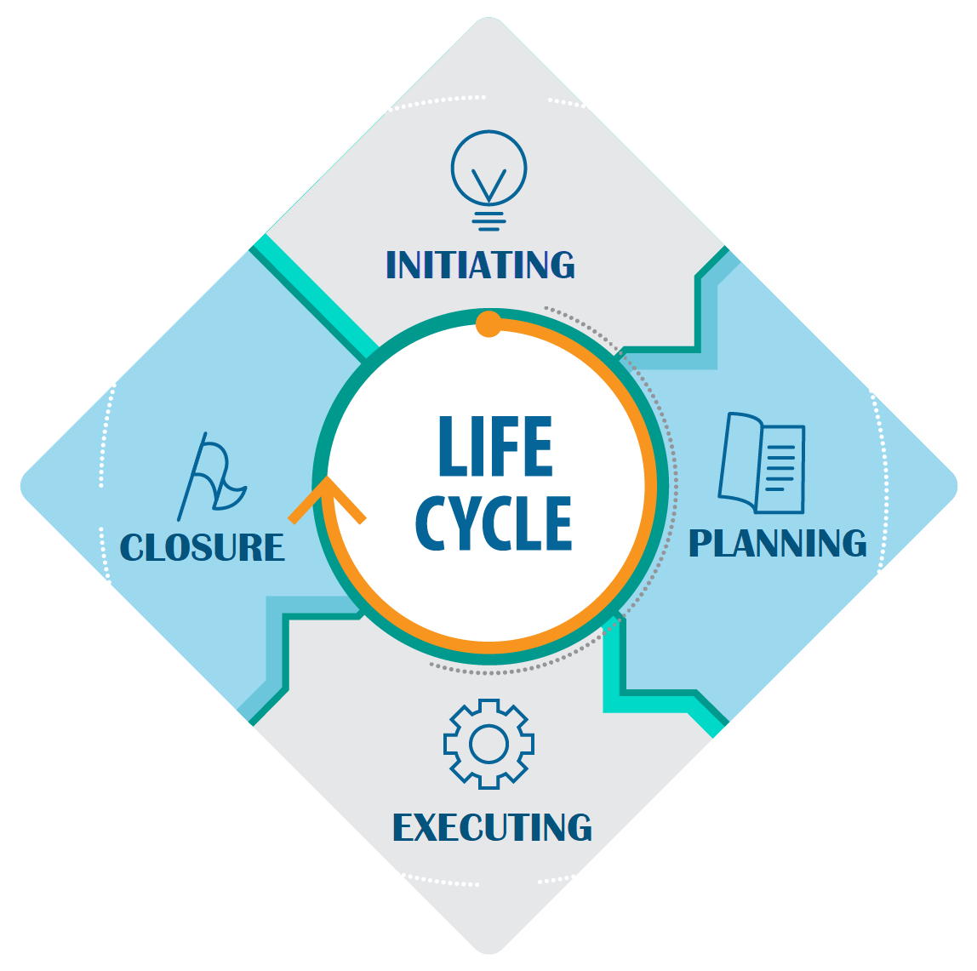

*Fig 1: Project Methodology*

#### **Project Plan**

Planning is the most important activity in the development of any kind of software. It consists of studying through requirements of the system. That is what all things are to be required in the completion of the project. It consists of pre-planning and post-planning consists of understanding the system requirements. Post-planning consists of how the system will work, what will be its limitations, etc.

#### **Schedule Representation**

|  |  |  |  |
| --- | --- | --- | --- |
| **TASK NAME** | **START** | **END** | **DURATION** |
| Requirement Gathering | 26 DEC, 2022 | 11 JAN, 2023 | 15 |
| Analysis of require | 11 JAN,2023 | 27 JAN, 2023 | 15 |
| System Design and Coding | 30 JAN, 2023 | 1 MAR, 2023 | 31 |
| System design and testing | 01MAR, 2023 | 16 MAR,2023 | 15 |
| System Integration and Testing | 16 MAR,2023 | 30 MAR,2023 | 15 |
| Documentation | 01 APR,2023 | 10 APR,2023 | 10 |

*Table 2: Schedule Representation*

#### **RISK MANAGEMENT**

* + 1. **Risk Identification**

Risk Identification is a systematic attempt to specify threats to the project plan. By identifying the known and predictable risks, the project manager takes a first step towards avoiding them when possible and controlling them when necessary.

One method of identifying risks is to create a risk item checklist. The checklist can be used for risk identification and focuses on some subset of known and predictable risks in the following subcategories.

* + - * **Product Size**: - Risks associated with the overall size of the software to be built or modified.
      * **Business Impact:** - Risks associated with constraints imposed by Management.
      * **Customer Characteristics**: - Risks associated with the sophistication of the customer and the developer's ability to communicate with the customer in a timely manner.
      * **Process Definition**: - Risks associated with the degree to which the software process has been defined and is followed by the development organization.
      * **Development Environment**: - Risks about the availability and quality of the tools to be used to build the project.
      * **Technology to be built**: - Risk on the complexity of the system to be built and the newness of the technology

#### **Risk Analysis & Planning**

Regardless of the prevention techniques employed, possible threats that could arise inside or outside the organization need to be assessed. Although the exact nature of potential disasters or their resulting consequences are difficult to determine, it is beneficial to perform a comprehensive risk assessment of all threats that can realistically occur to the organization

#### **Types of Risks**

* + - * + **Performance Risk**: - The degree of uncertainty that the product will meet its requirements and be fit for its intended use. -As we are trainees, our project’s performance risk is there.
        + **Cost Risk**: - The degree of uncertainty that the project budget will be maintained. The cost of our project is already decided by management.
        + **Support Risk**: - The degree of uncertainty that the resultant software will be easy to correct, adapt, and enhance. The client of this project is in different premises.
        + **Known Risks**: - these are those that can be uncovered after careful evaluation of the project plan.
        + **Experience Risks:** - Are extrapolated from past project experience. As we are trainees, make this project no such experience is there.
        + **Project Risks**: - Threaten the project plan. If project risk becomes real, it is likely that the project schedule will slip and that costs will increase. The budget of this project was decided before starting the project and it is enough to complete it. All the works are divided between team members. Required all the resources are available.
        + **Technical Risks**: - Threaten the quality and timeliness of the s/w to be produced. If the technical risk becomes real, an implementation may become difficult or impossible. -Technology is already decided for this project.
        + **Business Risks**: - Threaten the viability of the s/w to be built. This is a live project, so no business risk is there.

#### **Risk Planning**

To mitigate the risks, project management must develop a strategy for reducing turnover. Among the possible steps to be taken are

* + - * + Meet with current staff to determine causes for turnover (e.g. Poor working conditions, low pay competitive job market).
        + Mitigate those causes that are under our control before the project starts.
        + Once the project commences, assume turnover will occur and develop techniques to ensure continuity when people leave.
        + Organize project teams so that information about each development activity is widely dispersed.
        + Define documentation standards and establish mechanisms to be sure that documents are developed in a timely manner.
        + Conduct peer reviews of all work.
        + Assign a backup staff member for every critical technology.

## 2.2 ESTIMATION

|  |  |  |  |  |
| --- | --- | --- | --- | --- |
|  | **Sr. No.** | **Features Milestone Division** | **App Development Timeline** | **Payment Milestone** |
| **1** | | * Kick Off Internal Meeting * Resource Allocation * Knowledge Sharing | - | **USD** **As an Upfront to start the Project** |
| **2** | | * **Wireframe Creation** * **Design Creation (PSDs + PSDs to HTML)** | **Working Days** | **USD  on completion of this milestone** |
| **3** | | * **Functionality Development for User:** * **Testing** | **Working Days** | **USD  on completion of this milestone** |
| **Total** | | | **Working Days** | **USD** |

*Table 3: Estimation*

#### **Effort Estimation**

While doing effort estimation we must keep in mind that the Website must be user-friendly. That is this Website can be interacted by any person who has a bit of knowledge about online shopping.

#### **Cost Estimation**

The target website aims at the person who will not be interested to buy expensive products. Hence the cost-effectiveness of the software was an important factor that had to be taken care of throughout the development process. These not only cuts down the cost but also help in being portable.

## 3. SYSTEM REQUIREMENT STUDY

## ASSUMPTION AND DEPENDENCIES

#### **Assumptions**

We will provide a friendly interface so that any user can easily navigate through the system, but he/she should be capable of providing a login name and password that has been provided to them by the administrator. The server used for data storage is always secured. The printer is present all the time when ever user wants to print a report.

#### **Dependencies**

Every new User must contact the Administrator for getting a new Login Id to access the system. All the normal users of the system will be assigned a specific set of roles. According to these roles, each and every user will be allowed access to a predefined set of features. The features that are assigned to each user will be decided by administrator.

# 4. SYSTEM ANALYSIS

## STUDY OF CURRENT SYSTEM

* + - First thing in the Analysis model is the Study of the Existing System, which is available. Without a Study of the Existing system Analysis Model cannot proceed.
    - Here the current system is manual system. In the manual system add new records of vehicles, drivers, services, trips, fuel and store in database.
    - Then on the basis of those details cases and hearings and so on added to database. And information of hearing and party details is also kept in database. Advocate can add, edit, view and details as per requirements in database.
    - So, rate of data redundancy is high because same data is needed to be stored in more than one place. And even if any of those books will be misplaced then no recovery or backup is offered.
    - And in this manual system no other person rather than admin or the person who is making entries can know or understand process detail or current status of the system.
    - And to make all the entries manually time consumption is very high. And retrieval of data becomes very tedious job.

# 4.2 NOT INCLUDED IN THE TASKS FOR THIS PROJECT

1. Hosting and Server
2. Image research/purchase/inclusion - Any images which you want to include will be provided by you.
3. Content- You will provide us all the required content.
4. Resolving any problems with your ISP, hosting provider or any other third parties.
5. Interaction with third parties not related to the scope of this project.

## 4.4 FEASIBILITY STUDY

An important outcome of the preliminary investigation is the determination that the system is feasible or not. The main aim of the feasibility activity is to determine whether it would be financially or technically to develop a project.

* + - **Economic feasibility: -** It does not require any other equipment and extra expenses in software, so it is economical.
    - **Technical feasibility:** - The technical issues usually raised during the feasibility stage of the investigation include the technology, the developer’s awareness about the technology, accuracy, reliability and expansion of the system. The following factors were considered for technical feasibility while developing this application. Here we preferred ReactJS with MongoDB behind for customizing the software, Moreover, owing to the user-friendliness of online shopping, we could concentrate more on core programming logic and in the development of necessary functions to implement the same.
    - **Operational feasibility:** - Operational feasibility measures how well the solution will work in the organization and how will end-users & management feel about system. The proposed system will allow the users to query and get appropriate and adequate information. The organization was very enthusiastic and optimistic with the development of the proposed system because prior to the development of the system, there was no provision for Spatial Querying. So, there was a lot of support from the organization for developing this project. Software should work properly according to the owner of the company.
    - **Schedule feasibility:** -Software must be completed within one year.

**4.5 DATA DICTIONARY**

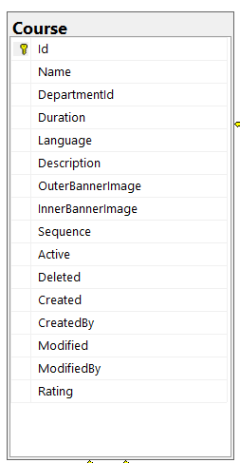 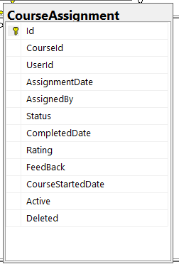 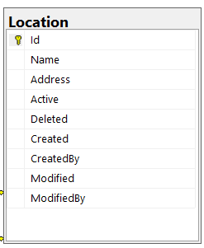

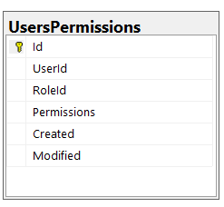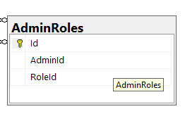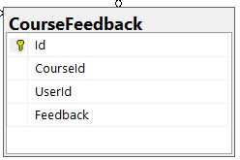

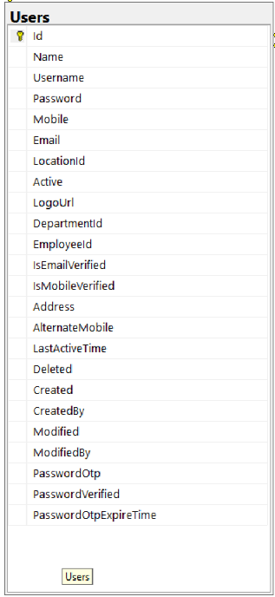 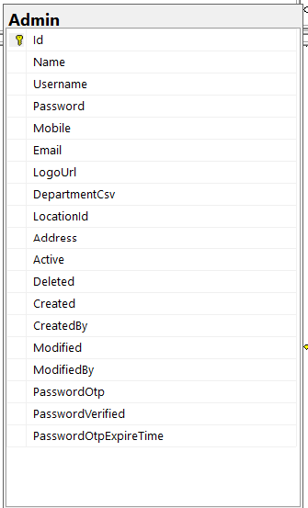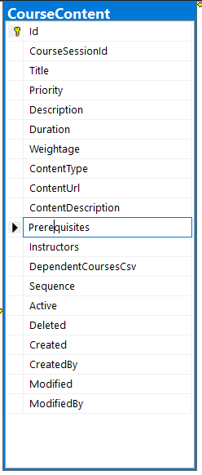

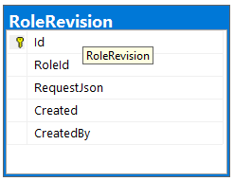 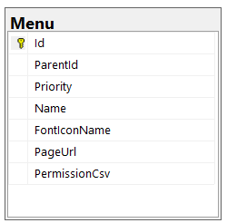 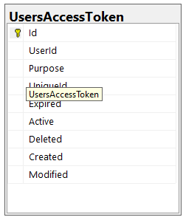

# 5. SYSTEM DESIGN

## USE CASE DIAGRAM

Use Case Diagram

*Fig 2: Use Case diagram*

## CLASS DIAGRAM

*Fig 4: Class Diagram*

**5.3 DATA FLOW DIAGRAM**

* + DFD LEVEL - 1

*Fig 5: DFD for TRAINING & DEVELOPMENT*

# 6.TESTING

Testing is important phase of the application development. After implementing the application and before delivering it to the client, it is necessary to verify that whether the code written is working properly or not. By testing the application, we can detect the logical errors in the code and can be able to correct them so that the client can get a perfect working application.

We have tested our application of Assets Management by inputting various valid and invalid data. We have checked all the input conditions required to store valid data. For this we have tried all the normal conditions as well as extreme conditions.

We have performed the process of testing at during the implementation phase as well as after the completion of implementation. We tested our application after the completion of each module by entering all kind of data and corrected almost all the incorrect working of the application we observed.

## 6.1 Unit Testing

Unit testing is focused on verifying small portions of functionality. Unit testing is important part where each module and process of application is to be test by possible input sets, range and desired output. Each Individual Module or process should generate (if any).

Applicable requirements are checked. Exercise every line of code. Check that the full range of possible input data works. Boundary analysis - logical statements that refer to threshold states are checked to ensure they are correct. Check for bad input data. Test for scientific validity.

## 6.2 Load Testing

In performing load testing, I have to simulate how users will use web application in the real world. The earlier perform load testing the better. Simple design changes

can often make a significant impact on the performance and scalability of web application.

A topic closely related to load testing is performance tuning. Performance tuning should be tightly integrated with the design of your application.

Testing presents an interesting anomaly for the software engineering activities; the engineer attempts to build software from an abstract concept to a tangible product. Now comes testing.

## 6.3 Models of Testing

There are different Models of testing. On the basis of testing methods there are two types of testing

## White-box testing

White-box tests are used to examine the procedural details. It checks the logical paths by test case. It can also check the conditions, loops used in the software coding. It checks that loops are working correctly on defined boundary value.

## Black-box testing

Black-box tests are used to demonstrate that software functions are operational, that input is properly accepted, and output is correctly produced, and that integrity of external information is maintained.

White-box testing sometimes called glass-box testing, is a test case design method that users the control structure of the procedural design to drive the test case. Always we are thinking that there is no necessary to execute or checks the loops and conditions, so large number of errors is uncovered. With using white-box testing methods, we have checked that; all independent paths within a function have been executed at least once; all logical decisions on their true and false side. All loops working correctly at their boundary values and within their specified conditions.

In our coding we test that all the loops work truly in each module. The one technique

of white-box testing is basis path testing. It contains two parts; one is flow graph notation and the second is cyclometer complexity. In flow graph notation we are checking logical control of flow. By using cyclometer complexity, we find complexity of our project structure.

## BLACK-BOX TESTING

Black-box testing focuses on the functional requirements of the software. That is black-box testing enables the software engineer to drive sets of input conditions that will fully exercise all functional Requirements for the program. Black-box testing is not an alternative to white-box testing techniques. Rather, it is a complementary approach that is likely to uncover a different class of errors than white-box methods.

We use in our coding to find errors in the following categories:

* + - * Incorrect or missing functions
      * Interface errors
      * Errors in database
      * Performance errors
      * Initialization and termination errors.

Unlike white-box testing, which is performed earlier in the testing process, black-box testing tends to be applied during later stages of testing. Because black-box testing purposely disregards control structure, attention is focused on the information domain.

By applying black-box techniques, we derive a set of test cases that satisfy following criteria. Test cases that reduce, by a count that is greater than one, the number of additional test cases must be designed to achieve reasonable testing.

### Level 1 – Build Acceptance Tests

Other related test cases ensure that adopters received the proper Development Release Document plus other build related information. The objective is to determine if further testing is possible. If any Level 1 test case fails, the build is returned to developers UN-tested.

### Level 2 - Smoke Tests

The objective is to determine if further testing is possible. These test cases should emphasize breadth more than depth. All components should be touched, and every major feature should be tested briefly by the Smoke Test. If any Level 2 test case fails, the build is returned to developers UN-tested.

### Level 2a - Bug Regression Testing

Every bug that was “Open” during the previous build, but marked as “Fixed, Needs Re-Testing” for the current build under test, will need to be regressed or re-tested. Once the smoke test is completed, all resolved bugs need to be regressed. It should take between 5 minutes to 1 hour to regress most bugs.

### Level 3 - Critical Path Tests

Critical Path test cases must pass by the end of every 2-3 Build Test Cycles. They do not need to be tested every drop, but must be tested at least once per milestone. Thus, the Critical Path test cases must all be executed at least once during the Iteration cycle, and once during the Final Release cycle.

### Level 4 - Standard Tests

These are Test Cases that would be nice to execute but may be omitted due to time constraints.

#### **Bug Regression**

Bug Regression will be a central tenant throughout all testing phases. When a Severity 1 bug fails regression, adopters testing team should also put out an immediate email to development. The Test Lead will be responsible for tracking and reporting to development and product management the status of regression testing.

## TEST CASE

1. **Test name**: Form Fill up

#### **Purpose**

* + - Text box: Checking the functionality of the Text box. Which can accept "Alphabets, Numeric, Special characters"
    - Push Button: Checking the functionality of the “Register/Update/Submit/Cancel” push button.
    - Radio Button: Checking the functionality of the Radio button.

#### **Precondition**

* + - As per different user, selection of form is different.

#### **Post-Condition**

* + - None

1. **Test Name:** Verify Login for Admin.

#### **Purpose**

* + - Ensure that the right users can login into application.

#### **Precondition**

* + - Each & every admin has own id or password for login process, which is provided by Application admin.

#### **Post-Condition**

* + - None

# 7. SCREENSHOTS

1. **Home**

**2. Sign Up**

**3. Forgot Password**

**4. Dashboard**

**5. My Profile**

**6. My Courses**

**7. Course Content**

**8. Admin Side Login**

**9. Admin Dashboard**

**10. Admin profile**

**11. Role List**

**12. User List**

**13. Department List**

1. **Course List**

# 8. LIMITATION AND FUTURE ENHANCEMENT

## Limitation

* Meet up functionality is not there.
* Admin can’t appreciate trainee.
* Admin can’t take any exam or quiz.

## Future Enhancement

* Admin can evaluate a user.
* Admin can generate a google meet-up
* Admin can make a quiz or exam.
* Admin can generate a completion of training certificate

# 9. CONCLUSION

Conclude that this site through you can order electronics items online. This project **“CONNECTCHAT”** is manage online course , where admin can manage all the course as per the users department.

This is the best use for IT companies that are giving courses to the new trainees. They can availed all the courses that are given by the admin and admin can easily watch the status of courses.

# 10. REFERENCES

To make this project we have taken the references from the below-given links.

⦁.NET DOCUMENTATION

⦁[.NET documentation | Microsoft Learn](https://learn.microsoft.com/en-us/dotnet/)

⦁PostgreSQL DOCUMENTATION

⦁[PostgreSQL: Documentation](https://www.postgresql.org/docs/)

⦁STACK OVERFLOW

⦁https://stackoverflow.com